
Installation and Maintenance Instructions

for Tri-Flex Loop® UL listed Assemblies

Installation

- Be sure all pipelines are supported so the Tri-Flex Loop does not carry the pipe load.
- Initial pipe misalignment must not exceed 1/8” in any direction.
- Install the Tri-Flex Loop with neutral face-to-face dimension as shown on the submittal drawing. If anchors are designed into the piping system, they need only be sized to accommodate the forces of the piping system, since the Tri-Flex Loop imposes no additional thrust forces.
- If the Tri-Flex Loop must be installed with an initial misalignment, compression, or extension, then the maximum allowable movements are reduced by the amount of the initial deflection.
- Verify that the movements of the system are within the design parameters of the Tri-Flex Loop being installed.
- The maximum system test pressure must not exceed 150% of the maximum rated working pressure of 175 PSI for UL536 assemblies.
- The Tri-Flex Loop alloy must be chemically compatible with the media in the piping system. If in doubt as to suitability, refer to a Chemical Resistance Data table or contact Flex-Hose Co. for guidance.
- The flanges on a flanged Tri-Flex Loop have the bolt holes straddling the hose centerline. The mating flanges should also straddle the centerline to avoid torque on the Tri-Flex Loop.
- When installing weld end Tri-Flex Loops, or when welding in the area of a Tri-Flex Loop, extreme care is necessary to ensure no weld spatter comes in contact with the braided hose sections. The filler metal and or shielding gas must be suitable for the type of welding being performed. The filler metal used to install UL536 assemblies must have a melting point exceeding 1000° F.
- In “nested” Tri-Flex Loop applications there will be individual tags on each Tri-Flex Loop to designate its location. This should be compared against the submittal drawing to ensure each loop is properly placed.
- To install a thread end Tri-Flex Loop unions must be used. Do not place wrenches on the braided portion or the collar of the Tri-Flex Loop. Use care not to torque the Tri-Flex-Loop while tightening the union.
- Use care when handling the Tri-Flex Loop during transportation, storage, and installation. The braided hose sections must not be allowed to bend, deflect, sag, or otherwise extend beyond their rated capabilities.
- The shipping bar is to keep the Tri-Flex Loop in its neutral end-to-end dimension during shipping and installation. After installation, the shipping bar should be removed.
- Because the Tri-Flex Loop is rated for motion either side of its neutral face-to-face, the capability can be doubled by pre-compressing or pre-extending based on the requirement. With the extreme flexibility of the Tri-Flex Loop this can easily be done in the field.
- All units must be installed in accordance with acceptable piping practices. The thread sealant, groove end gaskets, or flange gaskets used must be compatible with the material being conveyed. All mating fittings and installation hardware must be accordance with accepted piping practices.
- Verify that all field connections are leak tight under system pressure.
- SPECIAL NOTE: When installed in any configuration other than with the Tri-Flex Loop hanging down (vertical), the weight of the Tri-Flex Loop™ must be supported utilizing the support lug provided at two of the 90° elbows. A chain, cable, or other suitable means of support must be used to support the weight of the Tri-Flex Loop™ and the media being conveyed. Care should be used not to allow the chain, cable, or other support to come in contact with the braided hose sections of the Tri-Flex Loop. Any repeated contact with the braided hose section will cause exterior abrasion and thus pre-mature failure. [See reverse for application support suggestions.]
- SPECIAL NOTE: In accordance with specified installation/application requirements the elbow port is positioned to allow continual removal of condensate or gases. Proper fluid draining or gas purging techniques/practices must be followed to avoid safety issues/concerns.

Maintenance

- In the event of seismic activity, the Tri-Flex Loop should be inspected to ensure it has not suffered damage from movement greater than its designed capability. If there is any question as to whether excessive motion has occurred, the Tri-Flex Loop should be re-tested. If determined that excessive movement beyond design capability has occurred, the Tri-Flex Loop should be replaced.
- The Tri-Flex Loop should be inspected during routine maintenance to ensure there are no signs of external damage. Inspect for frayed or broken braid wires. Also inspect to ensure there is no damage to the hose. If such damage is found, the Tri-Flex Loop should be replaced.

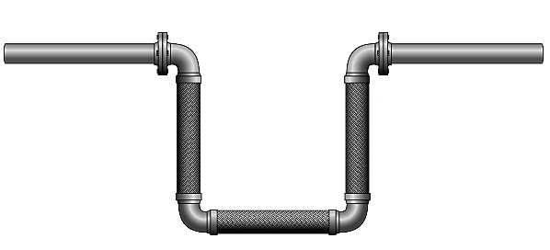
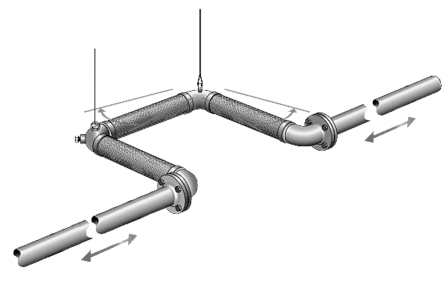

Horizontal Pipe Run with Vertical *Tri-Flex Loop®
Typical installation requires no further support of the Tri-Flex Loop

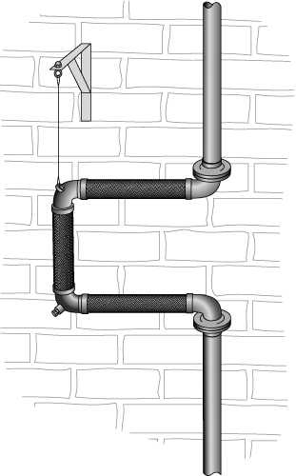

Horizontal Pipe Run and *Tri-Flex Loop®
The Tri-Flex Loop requires support at both elbows lugs with cable or other such device to carry the weight of the Tri-Flex Loop and the media conveyed.

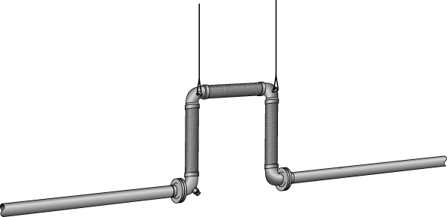

Vertical Pipe Run with Vertical *Tri-Flex Loop®
The Tri-Flex Loop requires support at the upper elbow lug with cable or other such device to carry the weight of the Tri-Flex Loop and the media conveyed.

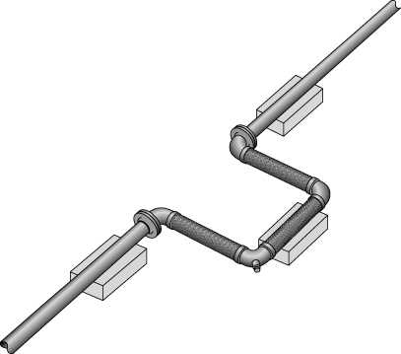

Horizontal Pipe Run with Vertical *Tri-Flex Loop®
The Tri-Flex Loop requires support at both elbow lugs with cable or other such device to carry the weight of the Tri-Flex Loop and the media conveyed.

Horizontal Pipe Run and *Tri-Flex Loop® on Floor
The Tri-Flex Loop requires elevated support to allow free movement from the floor. SPECIAL NOTE: The support under the non-parallel leg must be of a non-abrasive material to prevent damage to the braided hose of the Tri-Flex Loop

